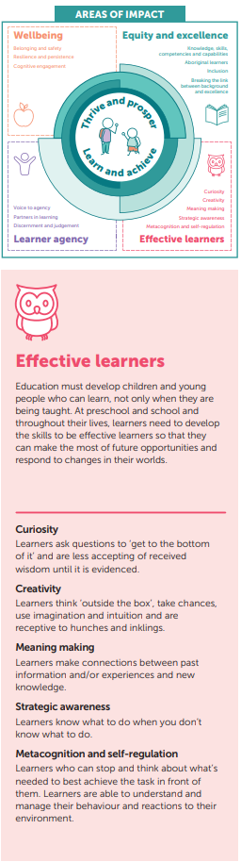 |  | PQIP |  |  | 
 | Goal | For children to reflect on their thinking and regulate their emotions during play.  When children engage in metacognitive processes, such as reflecting on their thinking and regulating their learning, the principles of the EYLF and Pedagogical Documentation/Making Thinking Visible can help create a dynamic and engaging environment that encourages self-awareness and self-regulation.
 | Actions |  | Educators Will | Learners Will
 | Facilitate Reflective Conversations  Ask open-ended questions to help children reflect on their thinking and learning strategies. Actively listen and guide them to recognise what worked, what didn’t, and how they can adjust. Encourage self-regulation by prompting them to set goals for improving their thinking and decision-making processes.  Provide Diverse Materials  Offer resources like art supplies and building blocks that promote critical thinking. Use tools like Floor books and tablets for children to document their reflections, helping them evaluate and improve their strategies. Encourage self-regulation by guiding children to assess their learning and identify areas for growth and development.  Engage Families  Share the importance of metacognition and self-regulation with families. Encourage them to support reflection at home by helping children recognise their thinking processes and regulate their learning. Invite families to provide insights on how children approach tasks and offer strategies to enhance their self-awareness and self-regulation. |  | Facilitate Reflective Conversations  - Encourage deeper thinking by asking open-ended questions to prompt children to reflect on their learning and thinking processes.  - Actively listen to children’s responses with genuine interest, guiding them to identify their thinking patterns and strategies for improvement.  - Participate in play and learning activities to model reflective and self-regulatory behaviours.  Provide Diverse Materials  - Offer a range of creative resources, such as art supplies, building blocks, and role-play areas, that encourage children to think critically and solve problems.  - Incorporate tools like Floor books and tablets to help children document and reflect on their play, enabling them to identify patterns in their thinking and actions.  - Support children's development by assisting them in recognising strategies to overcome challenges and extend their ideas.  Engage Families  - Foster strong relationships with families by learning about children’s interests, strengths, and previous knowledge, which can inform approaches to developing metacognition.  - Share the value of reflection and self-regulation and suggest ways families can support their child’s growth in these areas at home.  - Encourage family participation in reflection activities, promoting connections between home and school learning. | Engage in Reflective Conversations  - Respond to open-ended questions by reflecting on their thinking and providing thoughtful ideas.  - Share their thoughts, demonstrating self-awareness and regulation of their learning processes.  - Participate actively in play and learning, making decisions that reflect their developing self-regulatory skills.  Explore and Express Creativity  - Use diverse materials (e.g., art supplies, building blocks, role-play areas) to express ideas and engage in problem-solving, practising skills in metacognition.  - Document their play and reflections, learning to evaluate their thoughts, ideas, and actions in a structured way.  - Engage with educator-supported documentation to reflect on and refine their thinking, recognising strategies for improvement.  Collaborate with Families  - Build on their interests and strengths at school, supported by insights and contributions shared by their families.  - Reflect on and share their learning experiences, developing a clearer understanding of their learning processes.  - Participate in joint reflection activities with their families, strengthening connections between home and school and promoting self-regulation.

